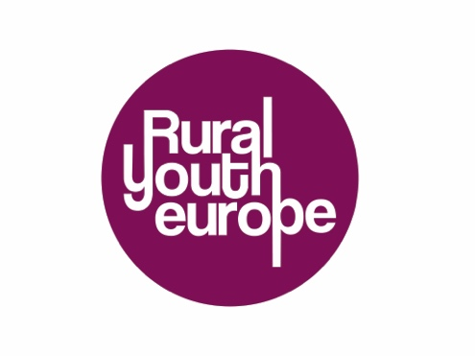
Submission Form
Rural Youth Project of the Year 2020
Project name:
Name of organisation:
Contact person for the project (Name, email and phone number):
I submit for
- Junior category
- Senior category
Project description (max 300 words):
- Why should your project be the Rural Youth Project of the year 2020?
- What was the goal?
- Where did the idea come from?
- Who was involved?
- What was the impact of this project on the community?
- How many people were involved in the project (approximately)?

The selection for the projects for public voting will be made by the Rural Youth Europe board. The winning project will be announced at the middle of April 2021.
Please send the completed application to your organisation.
Rural Youth Europe member organisations: Please submit applications and presentations to birgit.kuslap@ruralyoutheurope.com

