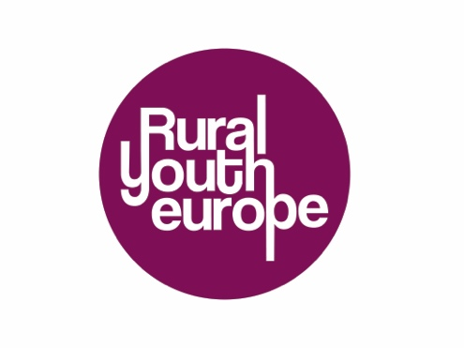
Submission Form
Rural Youth Enterprise of the Year 2020
Enterprise name:
Name of organisation:
Contact person for the organisation (Name, email and phone number):
I submit for
- Junior category
- Senior category
Project description (max 300 words):
Write a short motivational/ introductional letter why should this enterprise of the year 2020?

The selection for the projects for public voting will be made by the Rural Youth Europe board. The winning entree will be announced at the middle of April 2021.
Please send the completed application to your organisation.
Rural Youth Europe member organisations: Please submit applications and presentations to birgit.kuslap@ruralyoutheurope.com

